Grade 7 Accelerated · Unit 3 · Lesson 9  Writing Small Numbers in Scientific Notation  Independent Set 3.09 ANSWER KEY | Name  Date  Period

Six questions, on your own, in silence. Show the step that does the work.
1. Write 0.00047 in scientific notation.
4.7 × 10⁻⁴

2. Write 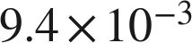 in standard form.
0.0094

3. Write 0.0000061 in scientific notation.
6.1 × 10⁻⁶
The 6 is in the millionths place.

4. Which is greater, 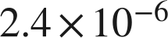 or 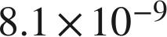 ?
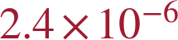
−6 is greater than −9.

5. How many times larger is 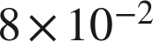 than 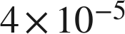 ?
2,000
8 ÷ 4 = 2, and 10⁻² ÷ 10⁻⁵ = 10³.

6. A computer displays a number as 3.7E−5. Write it in standard form.
0.000037

